Data Handling and Visualization (DSA06)
Name: Prasanna M Reg. No: 1925260244
Set 26: Student Performance Analysis
Question 1. Import the dataset in R. Plot a histogram for Math_Score. Draw a boxplot of Science_Score by Gender. Add proper title and labels. Interpret the results.
Program (R):
library(ggplot2)
student <- read.csv("Student_Mini_Data.csv")
ggplot(student, aes(x = Math_Score)) +
geom_histogram(breaks = seq(50, 100, 10), fill = "steelblue", colour = "black") +
labs(title = "Histogram of Math Score", x = "Math Score", y = "Frequency") + theme_minimal()
ggplot(student, aes(x = Gender, y = Science_Score, fill = Gender)) +
geom_boxplot() +
labs(title = "Science Score by Gender", x = "Gender", y = "Science Score") +
theme_minimal() + theme(legend.position = "none")
Output:
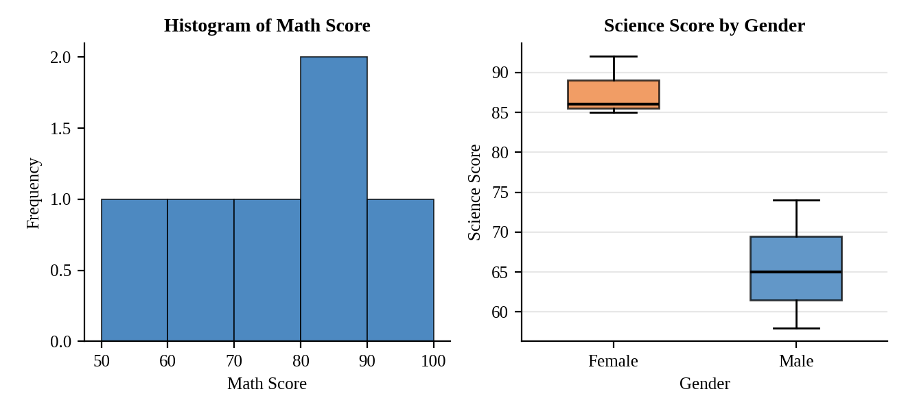
Interpretation:
Math scores are spread from 55 to 90 with the most students in the 80 to 90 band (2 of 6) and one student in each of the other bands. The mean is 73.5.
Female students have clearly higher Science scores (median 86, range 85 to 92) than male students (median 65, range 58 to 74). The two boxes do not overlap, so the gender gap is large in this sample; with only three students per group it should not be generalised.

Question 2. Create a scatter plot using R programming between Study_Hours and Math_Score. Use different colors for Gender. Add a regression line. Explain the relationship between study time and performance.
Program (R):
ggplot(student, aes(x = Study_Hours, y = Math_Score)) +
geom_point(aes(colour = Gender), size = 3) +
geom_smooth(method = "lm", se = FALSE, colour = "black", linetype = "dashed") +
labs(title = "Study Hours vs Math Score", x = "Study Hours", y = "Math Score") +
theme_minimal()
cor(student$Study_Hours, student$Math_Score)
Output:
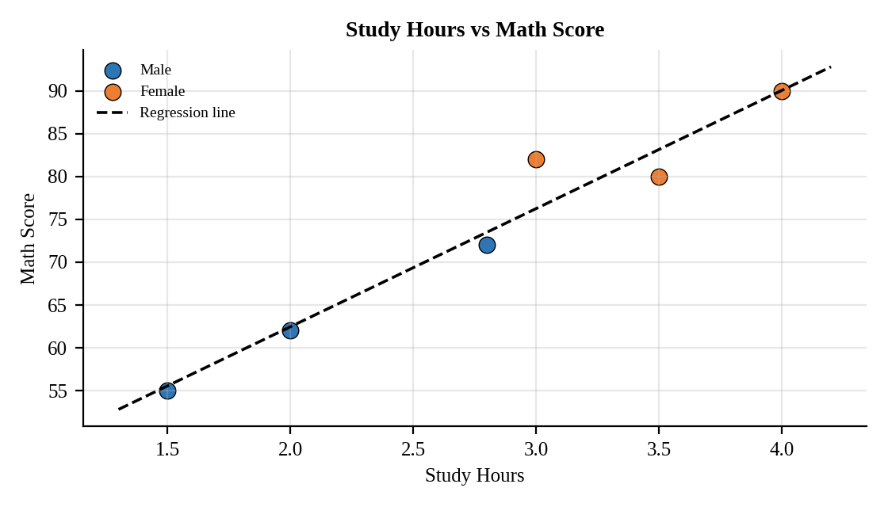
Interpretation:
There is a very strong positive relationship (r = 0.97). Each extra hour of study is associated with about 13.8 more marks in Math. The highest scorers (90 and 82) are female students who study 3 to 4 hours, and the lowest scorers (55 and 62) are male students who study 2 hours or less. This is an association from six students, not proof that study time alone causes the difference.

Question 3. Using R, convert Exam_Date into Date format. Calculate monthly average Math scores. Plot a line chart for the trend. Apply moving average smoothing. Identify any increasing or decreasing pattern.
Program (R):
library(zoo)
student$Exam_Date <- as.Date(student$Exam_Date)
student$Month <- format(student$Exam_Date, "%Y-%m")
monthly <- aggregate(Math_Score ~ Month, data = student, FUN = mean)
monthly$MA <- rollmean(monthly$Math_Score, k = 2, fill = NA, align = "right")
ggplot(monthly, aes(x = Month, group = 1)) +
geom_line(aes(y = Math_Score, colour = "Monthly average")) + geom_point(aes(y = Math_Score)) +
geom_line(aes(y = MA, colour = "Moving average (k = 2)"), linetype = "dashed", na.rm = TRUE) +
labs(title = "Monthly Average Math Score", x = "Month", y = "Average Math Score", colour = "") +
theme_minimal()
Output:
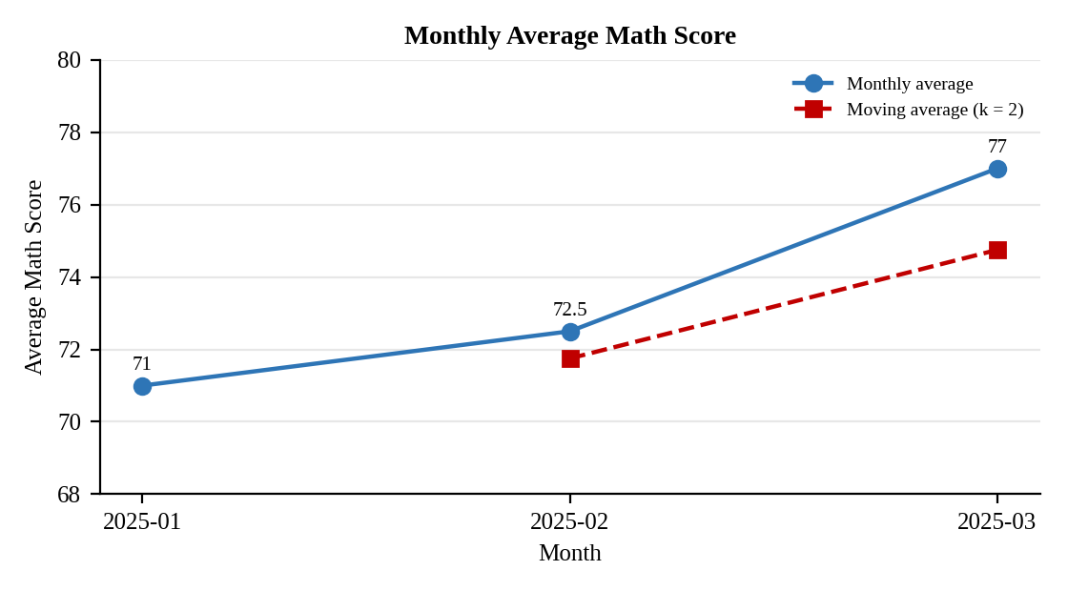
Interpretation:
The monthly average rises from 71.0 in January to 72.5 in February and 77.0 in March. The moving average (71.75, then 74.75) smooths the series and also rises, so the pattern is increasing, with the larger gain between February and March.

Question 4. Import Student_Mini_Data.csv into Tableau. Create a bar chart showing average Math scores by Gender. Create a line chart for score trends over time. Add a filter for Exam_Date. Design a simple interactive dashboard.
Procedure (Tableau):
1. Open Tableau, click Connect, choose Text file / Microsoft Excel, select "Student_Mini_Data.csv" and open Sheet 1.
2. Sheet 1 (Bar): Columns = Gender; Rows = AVG(Math_Score); Color = Gender; add labels.
3. Sheet 2 (Line): Columns = Exam_Date (Month, continuous); Rows = AVG(Math_Score) and AVG(Science_Score) (dual lines); add labels.
4. Right-click Exam_Date, choose Show Filter, select Range of Dates and apply it to both sheets.
5. Click New Dashboard, name it "Student Dashboard", set Size to Automatic and drag the sheets onto the canvas.
6. Select each chart and click the "Use as Filter" icon so that clicking a mark filters the other sheets; keep tooltips enabled.
7. Add a title to every sheet, adjust labels and colours, and save the workbook (File > Save As, .twbx).

Output:
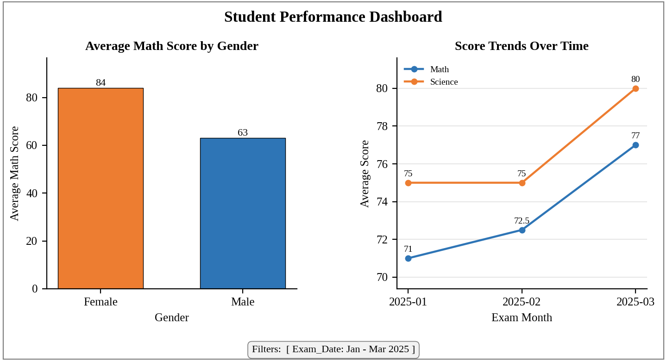
Dashboard layout (preview of the Tableau output).
Interpretation:
Female students average 84 in Math against 63 for male students, and both Math and Science averages rise from January to March. Narrowing the Exam_Date range updates both charts so a teacher can compare gender averages and trends for any exam period.

